

The constant trend seasonal component(small peak in winter, huge peak in summer)

Daily trend: peak in the morning and afternoon, no morning peak on Sunday

Additive model.

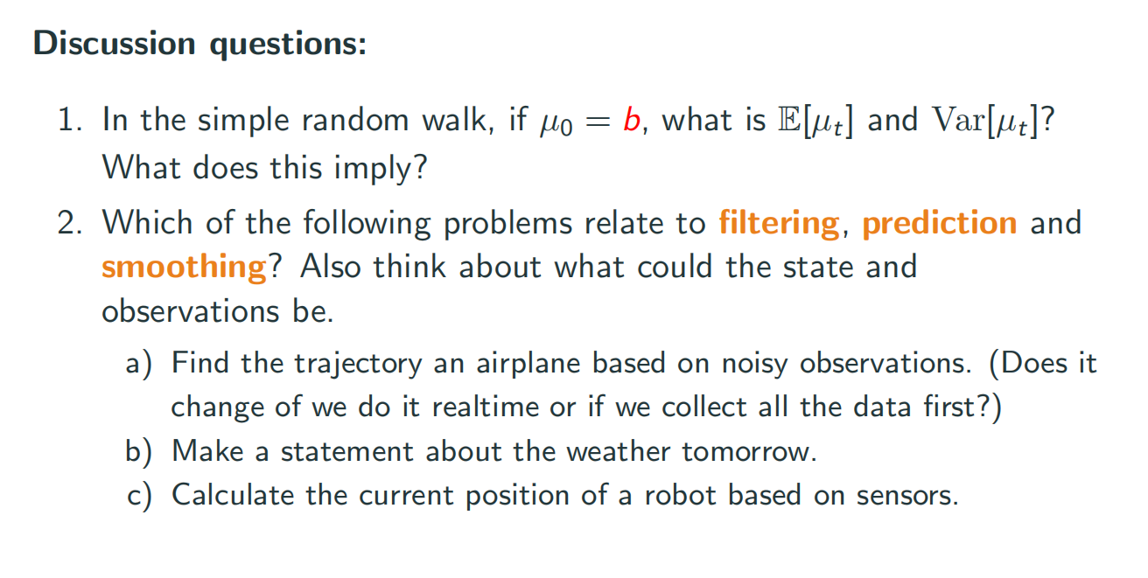

Mean value = b

Variance = P1+(n-1)\*sigma

Its not a stationary model.

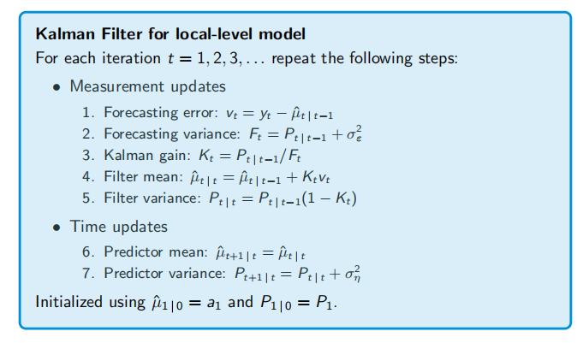

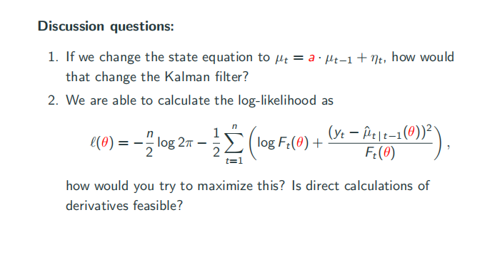

6 will be mu = a\*mu

7 will be p = a\*a\*p+sigma

EM algorithm

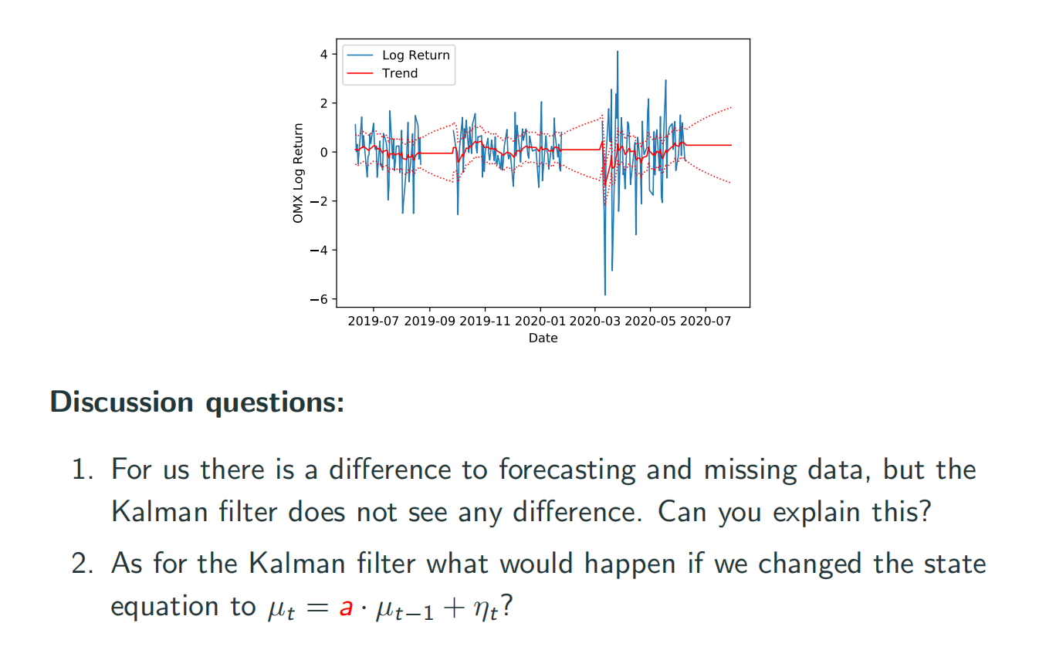

1 Kalmon fiilter dont know if there is missing data in the future. Cuz it runs iteratively. When it comes to missing data, it will just do prediction (skip step 1-5 directed to step 6 use previous estimator)

2 when there is missing data,we have no correctness, a will accumulated exponcialy.